LECTURE ANDROID APPLICATION v 1.0

Revision history:

|  |  |  |
| --- | --- | --- |
| Initial author | Anand Sunku | Draft v 1.0 |
|  |  |  |

**Table of contents**

1. Screens 4

1.1 Website 4

1.1.1 For ceo 4

1.1.2 For advertisement collectors 4

1.1.3 For advertisers 5

1.1.4 For marketing people 6

1.1.5 For general public 6

1.2 Android 7

1.2.1 Registration 7

1.2.2 Category screen 7

1.2.3 Question answer with video selected 8

1.2.4 Result screen 9

1.2.5 Summary screen 9

1.2.6 Background task 9

2. Stake holder benefits 9

2.1 Ceo 9

2.2 Advertisement collector 10

2.3 Advertiser 10

2.4 App marketing people 10

2.5 General public 10

5. Application security, scalability 11

5.1 Security: 11

5.2 Scalability 11

5.3 Reliability 11

5.4 Legal 11

9. Maintainence and enhancement plan 12

Total plan

1. Screens
2. Stakeholder benefits
3. Use case or flows
4. Functionality
5. Application scalability, performance, usability, security, reliability
   1. General test cases from the people who work in the companies in all the above non functional cases
6. Testing plan
   1. Load testing
      1. How many users at the max can use this site
      2. How to create so many users
         1. Should we call vijayms or some resource who can demonstrate
   2. Monkey testing
      1. Random behavior of the users using kids
   3. Dry run for 20 days // what is this testing called
      1. Automate the gui clicks Inside the phone and make it run for 20 days
7. Cost workout plan for 3 crores
   1. When this can get achieved
   2. How many people should we approach
8. Legal issues and publishing plan
9. Maintenance and enhancement plan
   1. Resources
   2. Strategy
   3. Bug fixing

# 1. Screens

## 1.1 Website

### For ceo

(nick name: Executive head)

* Should be with provision to do below details
  + see what videos are pending for approval.
  + see all the videos
  + search a video with tag
  + stop video from appearing.
  + Select a particular video and see the statistics as per the video
* Should be able to see statistics in descending order from most viewed to least viewed
  + Category
  + Which video
  + Most common search string
  + Who marketed more for the product, with help of token.
  + Should be able to see the list of tokens issued
    - Token consist of 2 parts
      * Id identifying the person.
      * Unique number identifying the token.
* Should have notification events
  + When the collector changes his password.
  + When the advertiser changes his password.
  + When the video is added and made to wait for approval.
  + If the video is waiting for approval for more than configurable number of days, it should appear in red.
  + Daily Top 10 numbers of people who got more money.
  + When a particular number is coming many times in a wild way, red notification with alert sms to the ceo should appear.
  + When ever there is a request to the collector from advertiser there should be a notification to the ceo as well
  + When there is a delay in the approval of the collector, the notification board should contain the message in red color. This is a high priority notification.

### For advertisement collectors

* Should be able to add a video
  + As part of adding a video, should be able to add supporting documents and upload the same to the web server.
    - Scanned copy of cheque, address proof, any agreement signed, photo of the shop & person of the advertiser.
* After collecting the documents if there are any pending details before sending for approval, the collector should be able to save the form.
* When the advertiser makes some modification, his application for approval has to be visible to the collector.
* After the video is added/modified/deleted, the state of the video should go to pending for approval.
* Should be able to see what video’s are pending for approval
* Should be able to sort by most recently approved to least recently approved,
* Should be able to see top 10 recently approved videos
* Should be able to see most recently modified videos and top 10 recently modified videos
* When the video is applied for deletion, there should be provision to attach supporting documents.
  + Reason for rejection, and any supporting douments
* Should be able to see temporarily stopped videos
  + Whose expiry date has reached (or)
  + Manually stopped with reasons.
* CEO page notification event list
  + If password is changed for the advert collector
  + If video is added/ modified/ deleted.
* The credentials (password) of the advertiser should not be visible to the collector.

### For advertisers

* If there is any issues with the login or password, or the details in the amount paid, or any other details, the advertiser should be given phone numbers, email id of our company ceo.
  + This should be visibile in the public page, under the advertiser page.
* If he is able to login and the details inside his page is with issues, he should be able to raise a issue/ticket.
  + There will be a button, will ask for issue description and submit button.
  + On Submit, the issue should be visible to the ceo as well as collector.
* Should be given login and password.
* Should be able to modify his details, and send the details for approval to the collector
* Should be able to see the money that he has paid.
* Should be able to see all the supporting documents that he has submitted.
* Should be able to see the expiry date of the video.
* Should be able to see the statistics of the video viewers
  + How many people tried to answer the question
  + How many passed/failed.
  + How many clicks per day.
* Maximum number of viewers allocated for his video
* Count of People currently viewed.

### For marketing people

* Enters his magic number and his mobile number
* Should be able to see how many numbers registered so far, with his magic number.

### For general public

When the expected answer and the applied answer matches, it should enter the scheme,

* Details of the winner of today, winner of the month, should be available both in the web as well as in the android phone.
* Winning is like bidding, if the guy is referring more people and trying more media, he stands a chance to win more.
* Based on number of click or views the user should be given more chance to win more money
* If the user is coming through train ticket selling or marketing his first chance of winning should increase.
* When the android application is asking for video list, highly paid video should appear first followed in descending order of paid amount, even if the amount paid is high, based on the remaining amount to exhaust the video should be sorted.
  + Or is it like once highly paid he should be given more courtesy than recently low paid.
* ~~The ticket selling people can play a drama along with some college goers making some gallata to create a crazy scene of winning.~~
  + ~~This may not be a good idea, since if the drama fails that news will spread wild.~~
* If the user is a valid user,
  + If he is not got the recharge yet, then he should be given provision to send a feeback.

## Android

### Registration

User should enter the below details, other than optional fields

1. name
2. phone number
3. email id (optional)
4. Reference number (optional)
5. magic number (optional) – this is given by people who market the product to the customer, who is using the phone.
   1. There should be a description under the magic number, which says the benefit of the same, but this field is optional.

If the user skips the mandatory fields, the login should not proceed. This can be ensured by the login button is enabled only after filling mandatory fields.

How it works

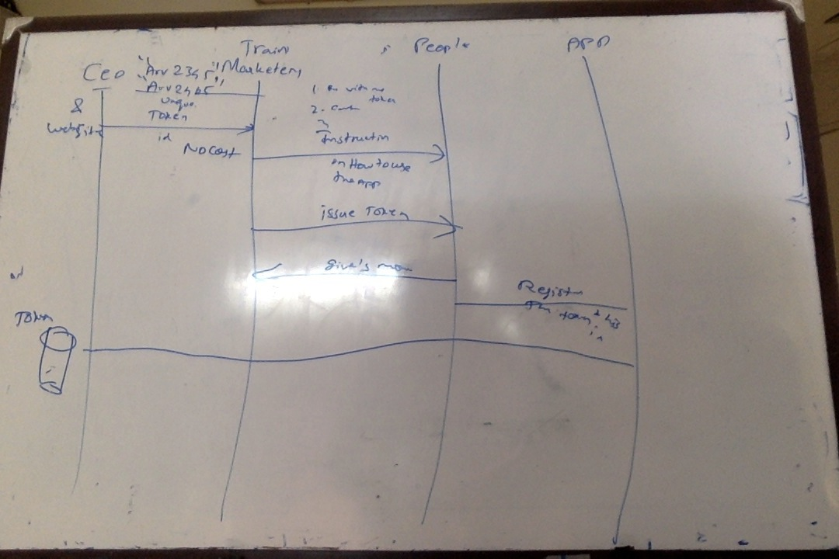

### Category screen

Category screen should contain the following

1. search bar
2. categories
3. video thumbnails in each category
4. should be able to scale as per the size of the phone
5. should be scrollable horizontally for videos in category
6. should be scrollable vertically for categories
7. when the user goes to the question and answer screen for viewing the video, when he comes back from the question & answer screen the category and the position of the video should be remembered
8. The search string entered by the users should be dumped into a database in the website.
9. Most common search string should be suggested based on the text typed by the user, this will be useful while collecting statistics.
10. GPS based category, area based offers.

### Question answer with video selected

Screen can be divided into 3 parts

1. First part
   1. Category->The title
   2. Video or slides (with dots and swipe) or text (with scrollbar)
2. Second part
   1. Questions can range from 1 to n, to view other questions he can horizontally scroll, the question along with answer should be scrolled.
   2. Options can range from 2 to 4
   3. The question and options should be visible even while the video is playing and the user can select the options
3. Third part
   1. The next button should be enabled only after completion of the lesson. ( to avoid skipping viewing of the advt).
   2. There should be option to view the contact details of the lecturer.
   3. For each contact number displayed, the user should be able to call the phone number, this can be simplified with radio button, like select a phone number
   4. The results should be stored in the web even if it is wrong or right.
   5. There should be back button to go back to the category screen.

After the next button is pressed, the unique details of the users (such as name, phone numbers) should be sent along with the answers to the website. The webpage should store this as statistics.

### Result screen

This screen will list all the status of the questions from 1 to n, as pass or fail.

### Summary screen

In this screen the user can see what is his

* Current credit point
* Total amount he has won

This screen should also contain option to send feedback to our website. With feedback text title (50 chars), detailed (300 chars) and a submit button.

### Background task

Time spent in each screen should be recorded and sent as report to the website.

The application should collect the list of all apps installed in the user’s phone, this will be useful to diagnose if any bad feedback has been provided by the particular set of user.

If possible

See what radio channel is being listened by the user and report the same to the ceo

See what tunein radio channel is being listened the user.

# 2. Stake holder benefits

## 2.1 Ceo

Why we are conducting this app

Expected questions from advertiser:

* Where is your office
* Who are the people running this website
* If there are any legal /technical / amount / communication issues how do we approach you?
* Is the company registered?
* What is the level of support
  + 24/7 ?
    - if any issues with video displayed or hacked displaying someother videos, what is the kind of support?

## 2.2 Advertisement collector

What are the duties performed by him.

What are the benefits for him?

When should his account be cancelled?

When should he be rewarded?

What are the legal documents that he has to sign?

Since this involves money

What are the address proofs that he has to submit?

* Address proof
* Photo of the shop if any
* Photo of the person

How can he hack our system?

## 2.3 Advertiser

What is the checklist while collecting the advt details?

What is the legal documents that he has to sign?

To be given to him

* Pamplets of our website
* Terms and conditions mentioned

## 2.4 App marketing people

## 2.5 General public

# 3. Use case or flows

Add/modify video upload process

Deletion of the video

Recharging schemes

Token based marketing

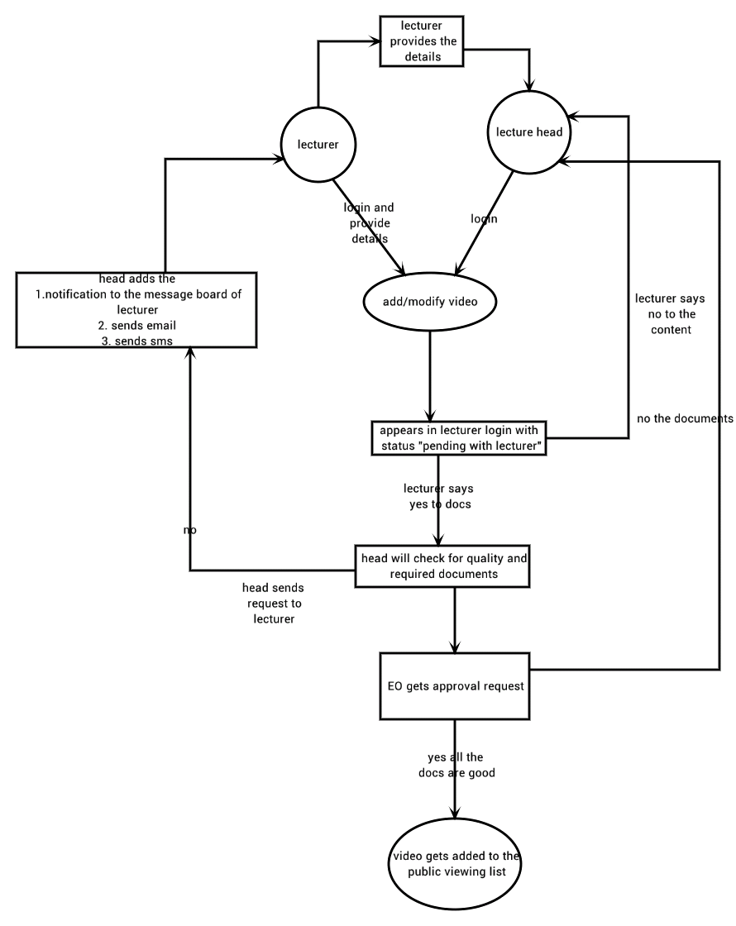

Marketing person issuing the token.

# 5. Application security, scalability

## 5.1 Security:

* + Since the database for approval can just be implemented as a flag, what are the security measures that has to be taken to avoid direct manipulation by the collector in the main database.
    - Ask this information to elam sir, tarun (senthil),
  + Should we do make verisign similar

## 5.2 Scalability

* + What is the maximum limit to which the android users can access the application
    - All the android users should scroll up and down at the same time, at that time what is the latency in the application.

## 5.3 Reliability

if there is issues in making a recharge or viewing the app, there should be a provision

* for the public to reach the ceo or collector.
* For the advertiser to reach the ceo or collector

## 5.4 Legal

* + Can we reveal the information of the end user to the advertiser, is there any legal issues associated with that,
    - Can that be addressed by placing any proofs or documents in the public website, without loosing the value of giving this information to the advertiser.

Cost workout

Should be with call center to ask any questions regarding the website, agents, advertiser, general public, marketing.

# 9. Maintainence and enhancement plan

if there is any crash in the application,

* What is the procedure for recovering the app from frequent crash
* What is the profiling tool for measuring the memory leak and memory usage
* What is the procedure for recovering the website from crashing

# Website

## Advertiser

### His fear

### Benefits

### Process

* Give his details about his business
* How he wants to improve his business
  + How different he is

Contents displayed in the Public web page content

* We will ensure Your advertisement is completely watched
* Every advertisement will have questions, this is to ensure complete understanding of your advertisement
* They will be rewarded with
  + recharge of the phone
  + Issuing offer coupons
  + Referral bonus
* We will provide the phone and email address of the viewing people
* We also give statistics who answered wrong and correctly so as to access your advertisement effectiveness
* We will give the time taken to answer your questions, even this is for the effectiveness of your advertisement.